STOCK PRICE PREDICTION

PHASE IV REPORT

Submitted by
Supervisor:- Ms. Harsh Sharma(E13523)
Co Supervisor:- Mr. Siroj Kumar Singh(E13617)

NAME OF THE CANDIDATE(S)
NAME - UID ANMOL SHAKYA - 20BCS5146
BUNTY PRASAD NAYAK - 20BCS1160
DEVANSH TIWARI - 20BCS1235

in partial fulfillment for the award of the degree of

BACHELOR OF ENGINEERING
IN
COMPUTER SCIENCE AND ENGINEERING


Chandigarh University
OCTOBER & 2022

CHAPTER 4.
RESULTS ANALYSIS AND VALIDATION

1.1. Implementation of solution -

import streamlit as st
# Streamlit is an open-source python framework for building web app. we are using in the program to build web app and show the result of ML algorithms.
# We can rapidly build the tools you need. Build apps in a dozen lines of Python with a simple API. Streamlit is a tool in the Machine Learning Tools category of a tech stack.
# Using it we can also works with TensorFlow, Keras, PyTorch, Pandas, Numpy, Matplotlib, Seaborn, Altair, Plotly, Bokeh, Vega-Lite, and more.

from datetime import date
# Python Datetime module , Using it we can get current local date and time .

import pandas as pd
# Pandas is a fast, powerful, flexible and easy to use open source data analysis and manipulation tool, built on top of the Python programming language.
# Pandas is the best tool for handling this real-world messy data. And pandas is one of the open- source python packages built on top of NumPy.

import yfinance as yf
# Yfinance is a python package that enables us to fetch historical market data from Yahoo Finance API in a Pythonic way.
# It becomes so easy for all the Python developers to get data with the help of yfinance. # We can easily download historical stock data from yfinance.

import plotly.express as px
#The plotly.express module (usually imported as px ) contains functions that can create entire figures at once, and is referred to as Plotly Express or PX.
#Plotly Express is the easy-to-use, high-level interface to Plotly, which operates on a variety of

types of data and produces easy-to-style figures.
#Plotly Express provides functions to visualize a variety of types of data. Most functions such as px. bar or px.

from prophet import Prophet
#Prophet is a procedure for forecasting time series data based on an additive model where non- linear trends are fit with yearly, weekly, and daily seasonality, plus holiday effects.
#It works best with time series that have strong seasonal effects and several seasons of historical data.

# from plotly import graph_objects as go.
from prophet.plot import plot_plotly, plot_components_plotly

# Get the current local date. START = "2016-01-01"
# TODAY = "2017-01-01"
TODAY= date.today().strftime("%Y-%m-%d")

# Main title in web app. st.title("Stock Price Prediction App")

# displaying all the possible stock
stocks =pd.read_csv('https://raw.githubusercontent.com/kaushikjadhav01/Stock-Market-Prediction- Web-App-using-Machine-Learning-And-Sentiment-Analysis/master/Yahoo-Finance-Ticker- Symbols.csv')

# creating a select box in web app.
selected_stocks = st.selectbox("Select Stock for Prediction",stocks)

# Loading data .
@st.cache #Cache the data so we don’t have to download the data again and again. def load_data(ticker):
data = yf.download(ticker,START,TODAY)

data.reset_index(inplace=True) return data

data_load_state = st.text("Loading data ")
data = load_data(selected_stocks) data_load_state.text("Data Loaded done ! ")

st.subheader('Stock data') st.text("(All prices are in USD)") st.text('Fixed width text')
# last 5 column will be printed of the selected stock st.write(data.tail())

# Plot the data on graph # #df = px.data.stocks()
fig = px.line(data, x='Date', y=['Open','Close'])
fig.layout.update(title_text = "Time Series Data" , xaxis_rangeslider_visible = True) fig.update_layout(
margin=dict(l=10, r=20, t=50, b=40),
)
st.plotly_chart(fig)

# Sliding bar
n_years = st.slider("Years of Prediction: ", 1,7) period = n_years*365

#Forecasting by train the dataset df_train = data[['Date','Close']]
df_train = df_train.rename(columns={"Date": "ds","Close": "y"}) m = Prophet()
m.fit(df_train)

future = m.make_future_dataframe(periods=period) forecast = m.predict(future)

# forecast[['ds', 'yhat', 'yhat_lower', 'yhat_upper']].tail() # st.write(forecast)
st.subheader('Predict Stock') st.write(forecast.tail()) st.write('Predict Stock')
# fig1 = go(m,forecast)
fig1 = plot_plotly(m, forecast ) st.plotly_chart(fig1) st.write('forecast Components')
fig2 = plot_components_plotly(m, forecast) st.write(fig2)

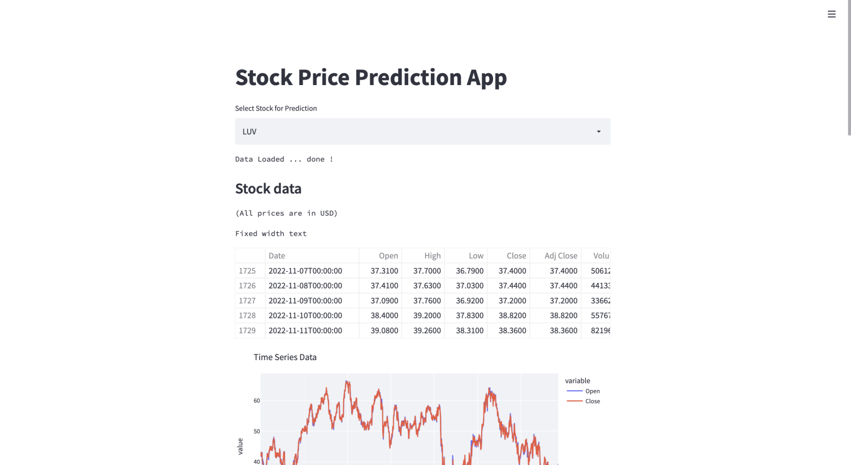

Fig.1 Dashboard Web App to predict Stock Price

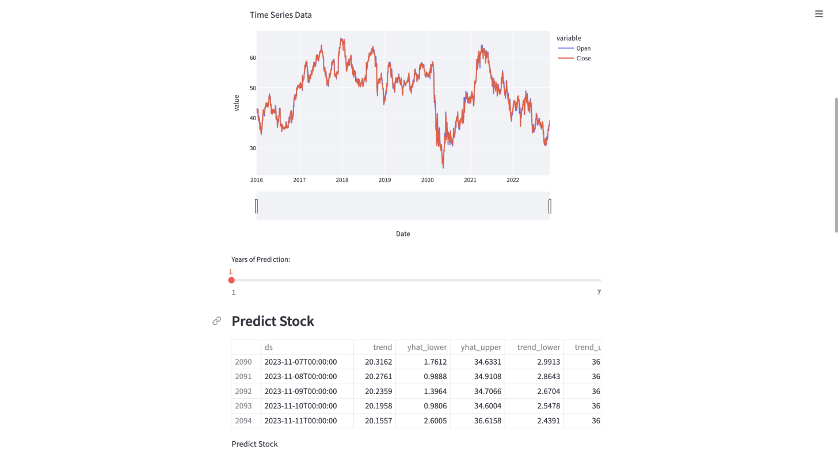
Fig.2 Slidebar to predict according to year

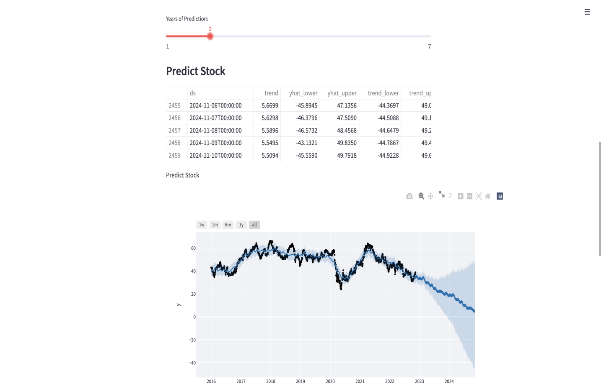
Fig.3 Plotting graph for prediction

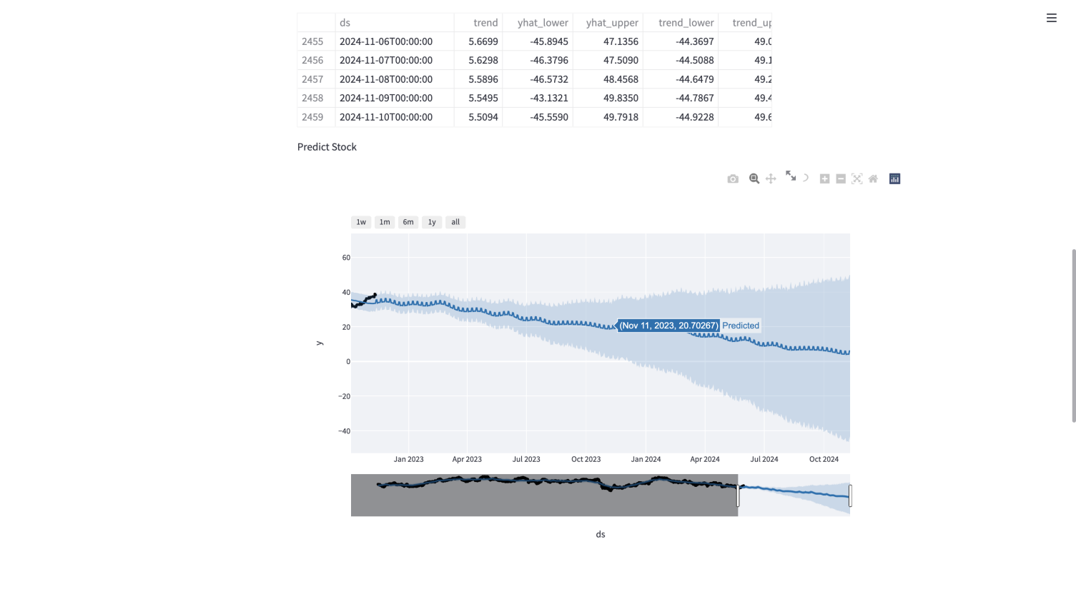
Fig.4. Prediction of stock in the months.
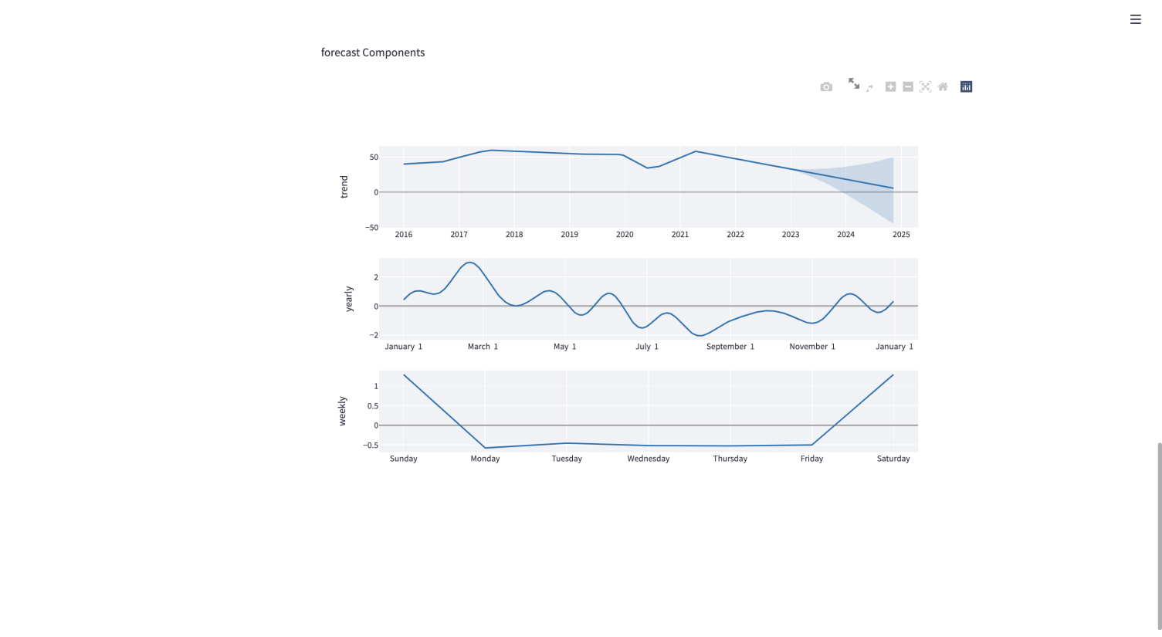

Fig.5 Forecast components on trend, yearly, and weekly basis.
REFERENCES
- A. Ben-Hur and J. Weston. A user's guide to support vector machines. In O. Carugo and F. Eisenhaber (eds.), Data Mining Techniques for the Life Sciences, pp. 223--239. Springer, 2010.
- Bing Search API. Windows Azure Marketplace.
- N. K. Chowdhury and C. K.-S. Leung. Improved travel time prediction algorithms for intelligent transportation systems. In Proc. KES 2011, Part II, pp. 355--365.
- A. Cuzzocrea, C. K.-S. Leung, and R. K. MacKinnon. Mining constrained frequent itemsets from distributed uncertain data. FGCS, 37: 117--126, July 2014.
- T. Finley and T. Joachims. Training structural SVMs when exact inference is intractable. In Proc. ICML 2008, ACM, pp. 304--311. ACM.
- D. Hodges. Is your fund manager beating the index? MoneySense, 15(7):10, Dec. 2013/Jan. 2014.
- T. Joachims, T. Finley, and C.-N. J. Yu. Cutting-plane training of structural SVMs. Machine Learning, 77(1): 27--59, Oct. 2009.
- D. E. King. Dlib-ml: a machine learning toolkit. JMLR, 10: 1755--1758, July 2009.
- V. Kolmogorov and C. Rother. Minimizing nonsubmodular functions with graph cuts-a review. IEEE TPAMI, 29(7): 1274--1279, July 2007.
- . K.-S. Leung, F. Jiang, and Y. Hayduk. A landmark-model based system for mining frequent patterns from uncertain data streams. In Proc. IDEAS 2011, pp. 249--250. ACM.

